JESUS – THE SUFFERING SERVANT

MARK 4:35-41

27 MARCH 2011

2ND STREET COMMUNITY CHURCH

GREGG LAMM, lead pastor-teacher
www.2ndstreet.org

Welcome again to a morning of worship at 2nd Street … I’m glad that you’re here. A lot of folks are away on Spring Break … but you’re here and that’s what matters! Turn to the person next to you and tell them something you’re hearing God say to you already this morning. Last Sunday, in our study of MARK 4:21-34 we looked at two parables of Jesus, THE PARABLE OF THE CROP and THE PARABLE OF THE MUSTARD SEED … and then we watched the 15-minute video “The Harvest” and received God’s instruction to us about the importance of us living out our faith in Jesus Christ in ways that are INTENTIONAL, OBVIOUS, AND CONSISTENT.

AM I INENTIONAL, OBVIOUS, AND CONSISTENT IN LIVING OUT MY LOVE FOR JESUS CHRIST AND MY FAITH IN JESUS CHRIST?

Gang, if we’re ever going to be truly partnered with God in what He’s up to in this world, we’ve got to invite God to pour THE foundational truth into our hearts and minds, that despite all the real reasons that God shouldn’t love us and use us, He’s crazy about us – and that as His followers when we live our lives like David talks about in PSALM 24:4, with “clean hands and clean hearts before God” … we’ll partner with God and help Him usher in the harvest that happens when we make up our minds that our lives are going be defined by journeying with people toward Jesus Christ.

WHAT ARE YOU HEARING GOD SAY TO YOU ABOUT
THE ROLE HE WANTS YOU TO PLAY IN THIS HARVEST?

Please take out your Bibles and turn back with me to MARK 4 … and we’ll dig into MARK 4:35-41 and invite God’s Word to get into us as we get into it. I believe that there are some life-altering, perception-altering, priority-changing lessons God has for us in these seven verses. Are you ready? Okay, let’s go. Here are three awesome works of art I found of this story … I’ll show them in their order of when they were created over nearly 2.5 centuries … 1695, 1853, and 1914.
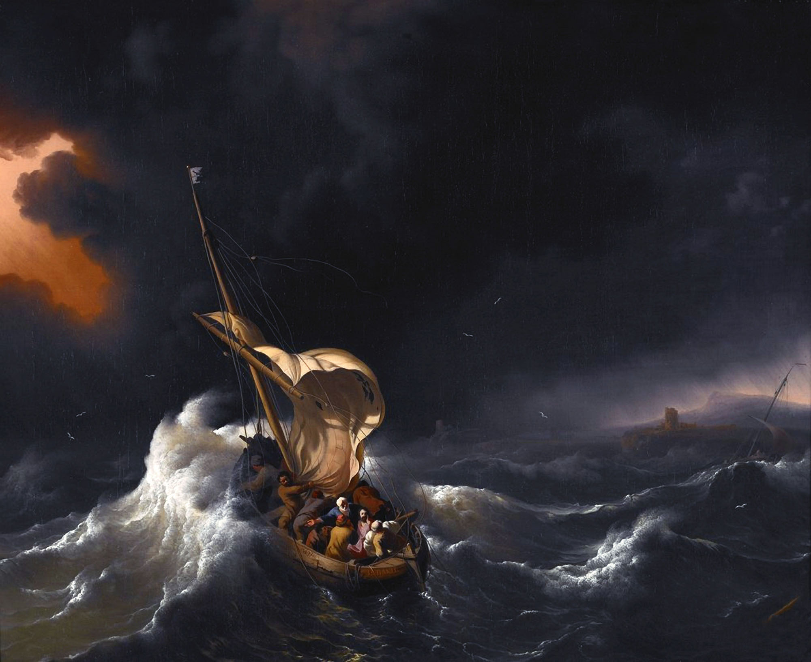
JESUS IN THE STORY
LUDOLF BACKHUYSEN 1695
[GERMAN / DUTCH]

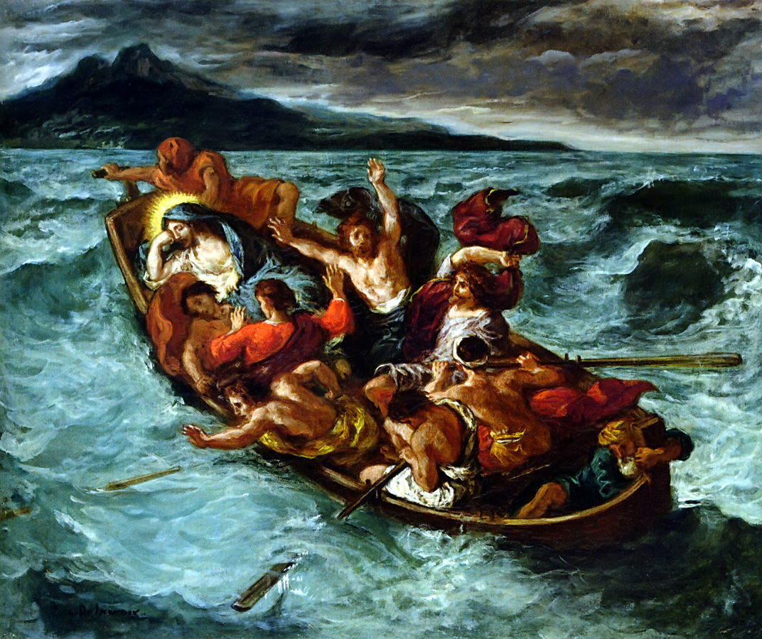

JESUS IN THE STORM

EUGENE DELACROIX 1853

[FRENCH]

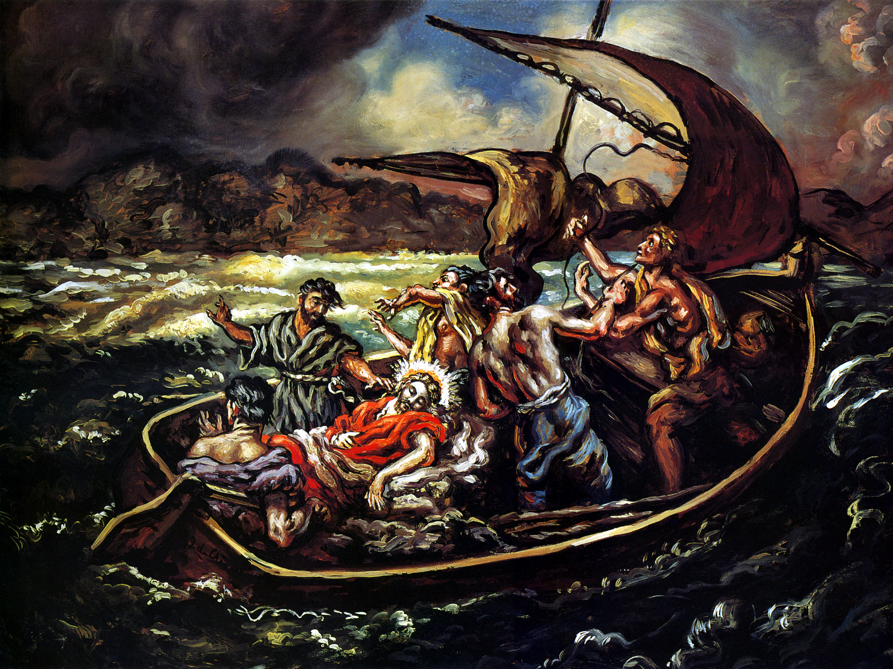

JESUS IN THE STORM

GIORGIO DE CHIRICO 1914
[GREEK / ITALIAN]

This is the first of two times that Jesus calmed the waves on the Sea of Galilee and saved His disciples from a storm. MATTHEW 14:24-33, MARK 6:48-52, and JOHN 6:16-21 tell us about another time when something like this happened later on in Jesus’ life … but that time the disciples were crossing the sea by themselves when a storm came up. And just when they thought were going to die, Jesus came down from the mountain where He was praying, walked out across the waves to them, and calmed the storm. It’s the story where Peter was so excited to see Jesus that he climbed out of the boat, and walked on the water toward Jesus, and then sank down into the water when he took his eyes off Jesus. Note to self, right?

v. 35 begins … On that day … in other words, on the same day that we’ve been reading about in MARK 4 … so later on that same, long day after Jesus had been teaching the crowds in parables … when the day was about done, Jesus told His disciples to get in the boat He’d been using as His “pulpit”, because they were going to head over to the other side of the Sea so that the next day they could continue their ministry journey South, down toward the Jordan River.

Gang, how easy it to just focus on the big price Jesus paid for us was when He went to the cross and endured the pain of dying on Calvary. And yet, EVERY DAY Jesus lived and ministered here on earth, He paid a price for us … EVERY DAY He laid down His life for us … EVERY DAY He showed us in His words, in His deeds, and in His priorities, the GOODNESS, the OBEDIENCE, and the PERSEVERANCE it took to step out of heaven so that He could step into our lives.

Jesus taught the multitudes throughout that whole day. He was spent and poured out. And so as He and the disciples took off in that boat to cross to the other side of the Sea of Galilee, it’s no wonder that Jesus fell asleep. And I see our FIRST FAITH LESSON here …

FAITH LESSON …

As Christ-followers, YOU and I need to follow Jesus’ example and live our lives for the faith of others … INTENTIONALLY, OBVIOUSLY, and CONSISTENTLY journeying with others toward Christ.

Listen to me … when you and I really grab onto the fact that none of us can take anything with us past this life except the people we’ve had a part in bringing to faith in Jesus Christ, and the crowns and the rewards we earn in this sacred work of journey with others toward Jesus Christ, then the only smart thing for us to do, is to pursue lives that are rich in the things that make for eternal life, and to hold onto everything else lightly … because it’s like what Job said in JOB 1:21 …

JOB 1:21 (NEW ENGLISH TRANSLATION)

²¹ Naked I came from my mother’s womb, and naked I will return there. The Lord gives, and the Lord takes away. May the name of the Lord be blessed!

Can YOU say that? Oh, friends, that you and I would mature in our faith in God, in our love of God … that we would mature in our lives with God to the place where we can speak these words from the depth of who we are … and mean them with the power and with the conviction of Job.

I’ll teach more on these crowns Scripture speaks of, which are the rewards we earn and receive here on earth, and that come with us to heaven, as we continue in our study of MARK. But I’m going to move off the text here in MARK 4 for a few minutes and share with you a synopsis of the four crowns and rewards God’s Word tells us that we receive as followers of Jesus Christ when we truly begin to seek first the Kingdom of Heaven (MATTHEW 6:33) in the here-and-now of life …

- THE CROWN OF LIFE (JAMES 1:12; REVELATION 2:10; 3:11)

THE CROWN OF LIFE is a reward specifically given to followers of Jesus Christ who’ve endured temptation and persecution because of their faith, and who’ve remained faithful until death, to the vows they’ve taken toward God.

- THE CROWN OF INCORRUPTIBLE RIGHTEOUSNESS (FIRST CORINTHIANS 9:24-27; FIRST TIMOTHY 4:7-8)

THE CROWN OF INCORRUPTIBLE RIGHTEOUSNESS is a reward given to followers of Jesus Christ who’ve run the spiritual race that’s been marked out for them by God. This is the reward we receive at our death, at the moment when our eternity with God begins, when we hear Him say, “Well done, good and faithful servant” (LUKE 19:17) … you’ve fought the good fight, finished the course, and kept the faith (FIRST TIMOTHY 4:7).
- THE CROWN OF REJOICING (FIRST THESSALONIANS 2:19; PHILIPPIANS 4:1-3)

THE CROWN OF REJOICING is a reward specifically given by God to His followers who’ve been personally involved in leading other people into a relationship with Him. Oh, Jesus, may this become the passion for each of us as Your followers … that we play an integral, intentional, consistent, and obvious part in the spiritual Harvest You want to see take place in the earth … because the harvest will come through God’s power, and through our partnership with Him as we journey with people toward Christ.

- THE CROWN OF GLORY (FIRST PETER 5:1-4)

THE CROWN OF GLORY is a reward specifically given by God to those who “feed the flock” and are “examples to the flock.” Now don’t think for a minute that this is a reward that will only be given to pastor and teachers. Not on your life. Because, again if you’re obviously, intentionally, and consistently living out the example of Jesus Christ, in your thoughts, in your words, in your deeds, and in your priorities … humbly showing others within the Body of Christ how to stay on target with God, then this crown awaits you in heaven, and you’ll experience the rewards of it in the here-and-now of the day-day circumstances of your life.

As we continue through MARK verse-by-verse, I want to encourage you to keep these crowns and rewards in mind … but be careful to not slip into the fatal flaw of thinking that being a follower of Jesus Christ is about doing good works so that God will love us and accept us.

BUT INSTEAD, be sure to keep in mind the truth that God ALREADY LOVES US and that HE’S EXPECTING US TO GROW, CHANGE, MATURE, AND EXPERIENCE TRANSFORMATION … and that as this happens, you and I will experience the blessings of these crowns and rewards, both in the here and now, and for all eternity. And I see our SECOND FAITH LESSON here …

FAITH LESSON …

We’re not studying the earthly life and ministry of Jesus Christ in MARK so we can give Jesus a standing ovation – but so we can see how Jesus Christ lived life and then courageously follow His lead.

Here are some examples of how you and I can journey toward Jesus Christ with the people He brings across our paths, and within the communities of faith God has led us to here at 2nd Street and beyond …

- Active witnessing, telling others about how Jesus Christ has changed, and is changing our lives.
- Helping our neighbors and fellow 2nd Streeters in the challenges they’re facing, but doing this in ways that show that our efforts are Christ-motivated, and not self-motivated.
- Helping an older person in our neighborhood with their yard work, or offering to take them to the doctor or run other errands.
- Bringing meals to people in need.
- Being a good listener to someone going through rough times.
- Anonymously contributing (financially or otherwise) to someone whenever you’re led by God to do so.

All these kinds of activities and more further the Kingdom of God, and give us opportunities to participate with God in the MISSION we’ve been called to here at 2nd Street … TO BECOME MORE LIKE JESUS CHRIST BY LOVING GOD, LOVING PEOPLE, AND SERVING OUR WORLD. In MATTHEW 10:42, Jesus said just giving a cup of water to a thirsty traveler is the same as giving it to Him. Gang, when we love and serve others with our whole hearts, as though we’re doing it for Jesus Christ Himself, it’s then that we’re laying up treasures in heaven (MATTHEW 6:19-21).

MARK 4:35-37 (NEW AMERICAN STANDARD BIBLE)

³⁵ On that day, when evening came, He said to them, “Let us go over to the other side.”
³⁶ Leaving the crowd, they took Him along with them in the boat, just as He was; and other boats were with Him.
³⁷ And there arose a fierce gale of wind, and the waves were breaking over the boat so much that the boat was already filling up.

The Sea of Galilee is 150 feet deep at it’s deepest point, 13 miles long at its longest point, North to South, and 8 miles wide at its widest point, East to West. And where Jesus and the disciples are right now, up on the North end, the Sea of Galilee was about 5 miles across. Ever rowed or sailed a boat 5 miles? Even without the storm, this wasn’t a simple voyage.

v. 37 … And there arose a fierce gale of wind, and the waves were breaking over the boat so much that the boat was already filling up … The Sea of Galilee, like most other large lakes around the world, is well known for its sudden, violent storms. Remember the Gordon Lightfoot song, “The Wreck Of The Edmund Fitzgerald”? It was a ballad about the sinking of a huge freighter named The Edmund Fitzgerald that sunk on Lake Superior in a violent storm on 10 November 1975.

Lake storms can be vicious. The Edmund Fitzgerald was 729 feet long, and the boat Jesus and His disciples were on was probably little more than 30 feet long. In fact, in 1986, brothers Moshe and Yuval Lufan found a 1st-Century fishing boat preserved in the mud on the NW shore of the Sea of Galilee. Known as The Jesus Boat, here’s a picture of what it looks like in the museum that was built to house it …

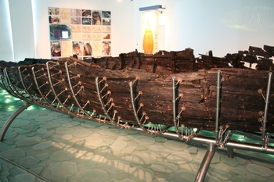
I love what 20th-21st Century American theologian and Bible expositor Warren Wiersbe writes about MARK 4:35-37 in his commentary on MARK, Be Diligent …

“Jonah ended up in a storm because of his disobedience, but the disciples got into a storm because of their obedience to the Lord.”

And so the disciples got into the boat with Jesus and took off. It doesn’t say they went back to shore or that they ate dinner. Jesus just gave them some instruction, and they followed. Oh, friends, what an example FOR YOU AND FOR ME TO FOLLOW. We don’t get to invent or make up the Jesus we want to follow, according to our rules and our protocols. We’ve got to take Jesus as He is, and make the choice to live our lives in obedience to the instruction He brings to us. And I see a THIRD FAITH LESSON for us from this story this morning …

FAITH LESSON …

Whether it’s a promise Jesus Christ gave to His disciples 2,000 years ago, or a promise He gives to you or me today, TIMES OF TESTING ALMOST ALWAYS COME AFTER TIMES OF TEACHING.

Listen … when we’re on the battle lines of ministry doing significant things for the Kingdom of God and obediently living in the direction God is giving us, Satan’s attacks against us will often escalate. I’m not saying this to scare us, but so that we’ll make the choice to invite God and His Word to MENTALLY EQUIP US. That way when the attacks come, we won’t be taken by surprise.
Being mentally prepared for a spiritual attack is important, because when we’re familiar with Satan’s tactics, his assaults won’t take us off guard or by surprise … and then even when they’re intensifying, we’ll be equipped to recognize and resist every demonic attack, rejoicing in the strength, discernment, and courage of the Lord.
This is the kind of attack Jesus and His disciples came under on the night we’re reading about here. Look ahead to MARK 5 and you’ll see that Jesus was going across the Sea of Galilee that night so that the next day He could cast a whole legion of demons out of a man who was an important weapon in what Satan was doing in the area … because through him Satan was holding this countryside hostage with fear.

This storm didn’t just come out of nowhere. Satan had a lot to lose if Jesus and His disciples made it all the way across the Sea of Galilee that night. Do you see it? Let’s look a little deeper into v. 37 …

The phrase there arose in v. 37 is from the Greek word ginomai, which as it’s used here describes something that happened unexpectedly or that caught everyone off-guard. In other words, the Apostle Peter (remember this is his Gospel, told through the pen of his scribe Mark) … the Apostle Peter is telling us that the disciples weren’t expecting a storm that night, and were taken by surprise. And to let us know the size of this storm, Mark uses the Greek word mega … translated here as fierce, which describes a storm of massive proportions … it was a mega-storm with mega-winds!

ILLUSTRATION … When I was growing up my dad and mom had a beach house at Pacific City that my mom’s dad left to us … and we also had a dory that my dad fished out of for years off Cape Kiwanda.

I remember my dad’s dad Charlie going out to fish with us, and he wouldn’t take a Dramamine pill. “I won’t get seasick … don’t worry about me” Grandpa said. Well not only did we have to take grandpa back to shore about an hour after we launched, but he got so sea sick that a week later, while sitting in his recliner in his living room in Hillsboro, watching a deep sea boat bob up-and-down on The Outdoor Sportsman, he got sea sick again and had to run into the bathroom to throw up.

Ya, Grandpa, you won’t get sick! Whatever. After that happened my dad had a “If you don’t take Dramamine you don’t go out in my boat” rule. But he never took it. I guess getting seasick isn’t genetic!

The word wind in v. 37 is the Greek word lalaipsi … and it means that this was a turbulent, violent wind … a wind that could also accurately be translated as hurricane, cyclone, tempest, gale, or fierce squall. So, again, we know the storm Jesus came up against on this night was a formidable, crushing, overpowering kind of storm. And here’s what I hear Mark telling us about what was going on that night out on the Sea of Galilee …

And suddenly and expectantly — as if it came from out of nowhere — a fierce windstorm kicked up — a ferocious windstorm with gusts that were violent, turbulent, and overpowering.

MARK 4:38-39 (NEW AMERICAN STANDARD BIBLE)

³⁸ Jesus Himself was in the stern, asleep on the cushion; and they woke Him and said to Him, “Teacher, do You not care that we are perishing?”
³⁹ And He got up and rebuked the wind and said to the sea, “Hush, be still.” And the wind died down and it became perfectly calm.

v. 38 says that the disciples thought they were perishing. This storm was severe enough to scare a boatful of men, at least four of whom had spent their whole adult lives fishing not only on this same lake, but on this very part of the lake. And where was Jesus? He’s down in the stern, in the back of the boat, among the nets and the equipment, where apparently He had enough room to lay down on a cushion that was there. And the Greek word translated cushion, doesn’t mean a pillow … it means a small couch, or a padded bench.

And so as this storm brewed, and as the wind and the waves pounded the boat, Jesus slept peacefully and soundly on a little love seat in the stern. I guess Jesus wasn’t a light sleeper. From what we’ve seen so far in MARK, think with me about the worries that might have kept Jesus awake on this trip across the Sea of Galilee … about just some of what Jesus COULD HAVE BEEN worrying about that night …
- Jesus could have been worrying about this rag-tag group of disciples He’d chose to follow Him and be His students.
- Jesus could have been worrying about His family who thought He’d gone nuts and were embarrassed and scared by His actions.
- Jesus could have been worrying about the huge crowds who were beginning to follow Him, with their never-ending supply of wants and needs.
- Jesus could have been worrying about the religious and political leaders who were beginning to plot against Him.
- Jesus could have been worrying about the future – I mean He knew full-well that the cross was waiting for Him at the end of the three years of ministry that stretched out in front of Him.

And yet, even with all these things to worry about, Jesus slept. And in v. 38 we read that the disciples woke Him up. The wind didn’t wake Him up, the crying out of the disciples didn’t wake Him up, and the waves coming over the bow of the boat didn’t wake Him up.

ILLUSTRATION … This reminds me of when our sons were babies, Teresa could sleep through almost any noise in the house, but the littlest noise from one of them and man, her feet hit the floor.

And what did the disciples say to Jesus? “Teacher, don’t You care that we’re perishing?” This reminds me of LUKE 10:38-42 when Martha burst into the room and confronted Jesus with the words, “Don’t You even care that I’m in here doing all this work by myself!?” This was kind of a QUESTION and a REBUKE wrapped up into one. Again, at least four of the disciples in the boat that night were seasoned fishermen – they knew what to do. But they were also seeing what they could do … bailing out the boat, steering the boat, and rowing the boat, wasn’t cutting it! And apparently they were ticked off that Jesus wasn’t helping them out. But before we mock them, isn’t this what you and I so often do when we’re going through hard times, through turmoil, through persecution, through testing, through temptations, and through loss?

Much of the time when you and I are going through hard times, we think we’re the experts, and we just want Jesus to help us bail out our boat. We don’t want Him to take over, we just want Him to help us implement and bring success TO OUR PLAN. And because we’re so often just like Jesus’ disciples here, it’s important that we watch what Jesus did when they tried to treat Him like the hired help, instead of surrendering to the truth, that He was God. Let’s look at v. 39 …

v. 39 … He got up and rebuked the wind and said to the sea, “Hush, be still.” And the wind died down and it became perfectly calm. … The Greek word translated “be still” literally means “be muzzled.” “Hush, be still.” I have a funny feeling that Jesus was talking to both the storm, and His disciples when He said these words.

ILLUSTRATION … Gayle Erwin is one of my favorite pastor-teachers, and authors. And in his book The Jesus Style, he tells a story about being on a boat trip with a tour group on the Sea of Galilee when the wind, the rain, and the waves started to kick up. Sound familiar? A young man on the boat thought “What Would Jesus Do?” and so he stood up and spoke a rebuke against the storm. But when he shouted out, “Peace, be still” the rain and wind kept coming but the boat engine immediately cut out. Gayle ends the story by suggesting that “we always need to be careful to NAME and AIM our rebukes!”

To rebuke something isn’t to yell at it and say, “I rebuke you.” It’s to call something out of the dark and into the light … and to expose the truth of what’s actually going on. So Jesus didn’t just stop the wind and the sea from blowing and raging by telling them to “Knock it off”. When He said … “Hush, be still” He used the same words He often used when rebuking and silencing demons. In other words, I believe Jesus knew that THIS WASN’T FIRST AND FOREMOST A PHYSICAL OR NATURAL CRISIS … BUT THAT IT WAS FIRST AND FOREMOST A SPIRITUAL CRISIS.

Are you picturing this? Here’s Jesus — on the eve of one of the greatest miracles of His ministry – because in the morning He’d cast a horde of demons out of a poor man, and give him a new life that was rooted in God. And at the same time, here’s Satan, fearing that in just a few hours, he was going to lose one of his most highly prized weapons. And at this exact crossroads in time, this violent, turbulent windstorm burst onto the Sea of Galilee and upon Jesus and His disciples.
Don’t kid yourself … the occurrence of this storm at this exact moment was no accident. And likewise, the timing and the occurrences of the spiritual storms in your life, and in my life, and in the life of our church, are never accidental. But that night in the midst of the storm, Jesus woke up and took authority over the situation. Do you see it? Do you see it?

And we read here in v. 39, that when Jesus exercised His authority over this unseen turbulence, “the wind died down and it became perfectly calm”. And in doing this, Jesus Christ demonstrated that He was the Lord of the wind and the waves. And this deadly situation provided a great opportunity for His disciples then, and for you and me as His disciples right now, on 27 March 2011, at 620 Morton Street in Newberg, OR, to see, to learn, and to know in our knowers, once again that Jesus Christ is Lord over all! And I see a FOURTH FAITH LESSON for us here …

FAITH LESSON …
As was the case with Jesus that night out on the Sea of Galilee, Satan’s attacks oftentimes escalate whenever we’re right on the edge of a breakthrough, or right when we’re in the middle of God’s will.

And just like this event provided an opportunity for Jesus to demonstrate His power and authority, you and I need to see every spiritual attack against us as an opportunity to rise up, surrender OUR authority to the authority of Jesus Christ, and demonstrate who we are in Him! Gang, it’s my prayer that 2nd Street be a flock that’s mentally and spiritually prepared by the equipping that comes by studying God’s Word, and by learning to be people of prayer, to stand against Satan’s attacks.

Like the Apostle Paul instructs us in EPHESIANS 6, let’s put on the whole armor of God so that we’ll be equipped to stand against the plans and schemes of the Enemy. Let’s learn to rise up and take authority in Jesus’ name over the wind and the waves that come against us and our families. And let’s never forget that this is our golden opportunity to see a demonstration of God’s power flowing in us and through us.

MARK 4:40-41 (NEW AMERICAN STANDARD BIBLE)

⁴⁰ And He said to them, “Why are you afraid? Do you still have no faith?”
⁴¹ They became very much afraid and said to one another, “Who then is this, that even the wind and the sea obey Him?”

What did the disciples do or say that showed Jesus they had no faith? It was their question/accusation in v. 38 of “Teacher, don’t You care that we’re dying?” Gang, when we think Jesus doesn’t care about us, it shows we have no faith, because in that moment we’re not believing the truth about Who Jesus is, what He thinks about us, and what He’s able to do for us. It takes great faith to trust the silent, sleeping Jesus … to know in our knowers that He cares for us and works for us even when it DOESN’T SEEM LIKE IT. And yet, this is the kind of trust God wants to build in us.

Jesus’ disciples forgot the big picture – and you and I so often do the same thing. The disciples should have known that the front-page headline of the next morning’s CAESAREA GAZETTE wasn’t going to be that THE MESSIAH AND ALL OF HIS DISCIPLES DROWNED IN A BOATING ACCIDENT ON THE SEA OF GALILEE. Of all the people on the planet that day, you would have thought Jesus’ own disciples should have had great faith. And yet, how often do you think Jesus scratches His head in heaven and says to us, not with shame, but with a sad kind of disappointment …

After all I’ve done IN YOU and FOR YOU, how is it that you have no faith? Come on. Really?

Let’s look at v. 41 and we’ll wrap up … They became very much afraid and said to one another, “Who then is this, that even the wind and the sea obey Him?” The sea was calm and the boat had stopped rocking … you’d think that would have filled the disciples with peace … but apparently they were just as afraid AFTER Jesus calmed the storm as they were BEFORE. And they asked, “Who then is this?” It’s like that song we heard this morning, “Where Could I Go But To The Lord?” The Lord God Jehovah, Jesus Christ, is the only One who only has this kind of power and authority. It’s like what David wrote in PSALM 89:8-9 …

PSALM 89:8-9 (NEW LIVING TRANSLATION)

⁸⁻⁹ O Lord God of Heaven’s Armies! Where is there anyone as mighty as You, O Lord? You are entirely faithful. You rule the oceans. You subdue their storm-tossed waves.

What an amazing picture this story paints of the love Jesus Christ has for us. I love what 19th-20th Century British pastor-teacher, and theologian, G. Campbell Morgan said about this when he wrote …

“There are many Christians today who seem to think the boat is going down! And I’m tired of the wailing of some of my friends who take that view. The boat cannot go down. Jesus is on board.”

Sometimes you and I as Christ followers live like practical atheists … acting little differently than all the people in the world who haven’t yet invited Jesus Christ into the boats of their lives … not looking to or depending on Jesus Christ and to His resources in the midst of our storms … trying to do everything in our own strength and with our own, limited, always-lacking, human abilities. And to us this morning, Jesus says, “I love you. But for pity sakes, knock it off! It’s time for you to grow up and surrender to Me. I’m God and you’re not! I’ll get you through this storm. Just watch. Just trust. You’ll see.”

Let’s invite God to press the seeds of His instruction for us this morning deep down into us … so that in due season, God will be able to use these truths to hold us up when we’re falling down, to give us victory when we’re defeated, and to help us stay on our journey with Jesus Christ as our Lord and Master, when we’re tempted to take control of our own lives instead of remaining surrendered to God. Blessed be the Word of the Lord.

NEXT SUNDAY … GREGG LAMM WILL BE TEACHING FROM MARK 5:1-20 … COME PRAYING AND EXPECTING!

